Public, but Hard to Find: What Retrieval-Augmented AI Can Do for Utility Regulation
Draft for the Georgetown Tech & Public Policy
By Nora Guo Zhan
Suppose you want to know why Pepco's 2025 operations and maintenance expense moved the way it did in docket FC1176. The answer is public, because the District of Columbia Public Service Commission posts every docket filing to its official e-Docket system. Official search, however, finds documents by case number, title, date, and filing party, while the answer is almost never in a title. It usually sits somewhere inside a PDF, often in a table or a footnote.
Finding that answer means opening a few dozen candidate filings, searching each one by hand, and reconciling what they say. For a utility with a regulatory staff, this kind of search is part of the daily work. For a resident, a small advocacy group, or a reporter on deadline, the same search can take long enough that the question never gets asked at all.
That is why the central question behind PSC Docket Helper is not simply whether AI can answer questions about regulation. It is whether AI can answer them in a way that people can check for themselves.
PSC Docket Helper is a beta research assistant for public DC PSC dockets, built independently of the Commission. It uses retrieval-augmented generation, or RAG, to search the text of more than 150,000 public filings and to answer plain-English questions with the document name, the PDF page number, and a link to the official original. The design rests on a simple principle: in public records work, an answer is only as useful as the source behind it.

Why Utility Records Matter
Public utility commissions make decisions that reach nearly every household, including what residents pay for electricity and gas, how utilities spend on their systems, and what protections customers have. In the District, those decisions move through dockets, and the filings in those dockets are public.
Being public by law, however, is not the same as being accessible in practice. A single proceeding can collect hundreds of filings, and the evidence that matters is often spread across testimony, data responses, and exhibits. Utilities and large intervenors have staff who read these records for a living, while residents and small consumer groups usually do not. The process is formally open to everyone, but the cost of finding evidence falls hardest on those with the fewest resources.
Lowering that cost is therefore a policy question as much as a technical one. It shapes who can follow a rate case, who can test a utility's claims, and who can take part in a proceeding with evidence rather than impressions.

What the Tool Does
Users ask questions in plain English. When a question names a case, the tool searches within that case. When it names none, as in "Which DC PSC cases discuss low-income residential disconnections?", the tool searches across every indexed case. Follow-up questions such as "And for 2024?" stay with the cases the conversation has already discussed.
As of September 2026, the site's public health endpoint reports:
- More than 150,000 public PDF filings, about 99.5 percent of them searchable as text.
- About 40,400 cases in the cross-case search index.
- About 10.5 million distinct terms indexed across those cases.
Each answer includes citations assembled from the retrieved filings, and the links point to the official PDF and cited page so that readers can inspect the source themselves. In this sense, the tool is built to send readers back to the record rather than to replace it.
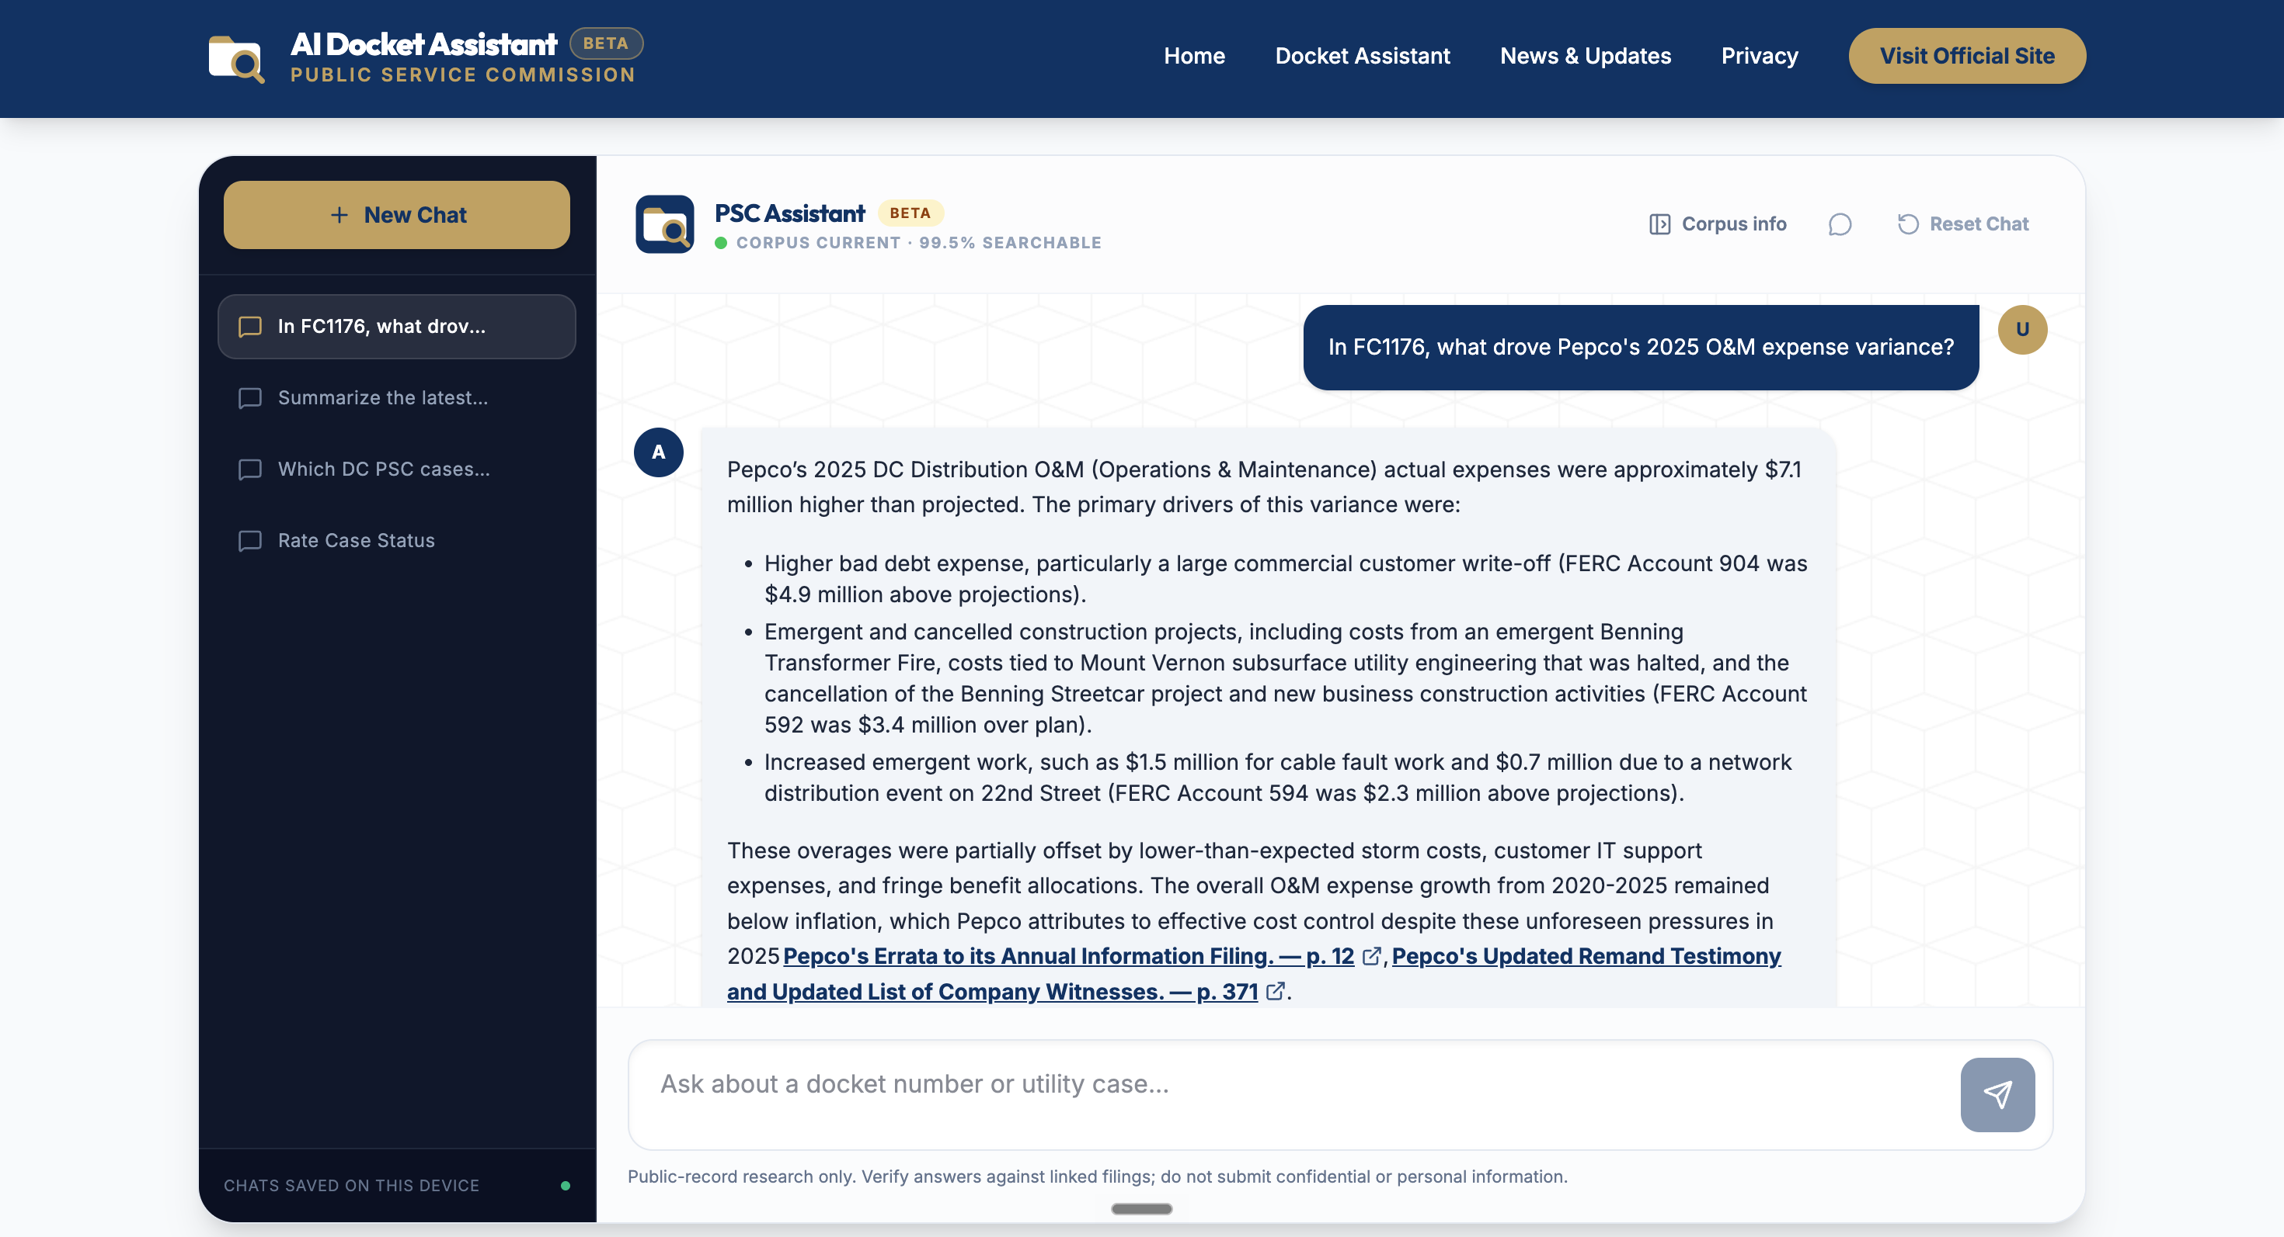
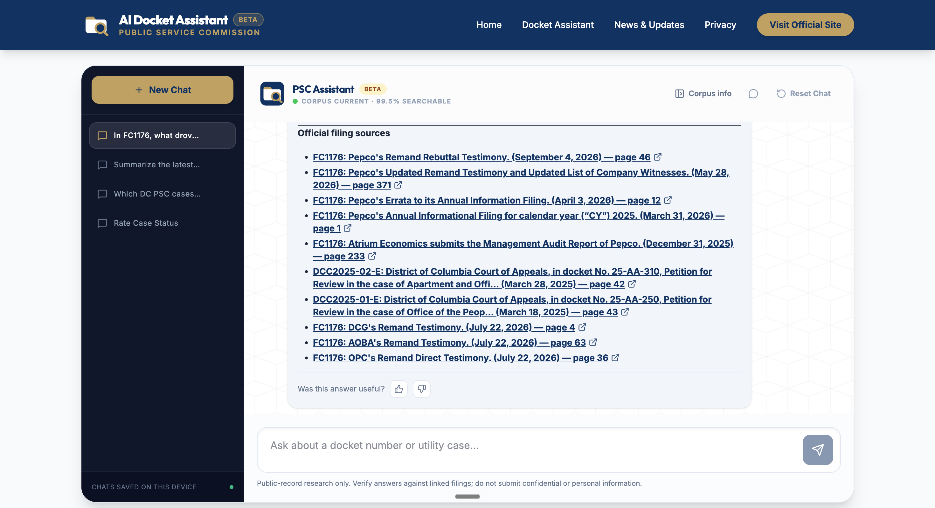
Figure 1. PSC Docket Helper answering the question that opens this post. The answer (top) cites the Pepco filings and pages it draws on; the list beneath it (bottom) links every filing retrieved for the question to its official PDF.

How the AI Works: Retrieval-Augmented Generation
Large language models write fluently, but they have two weaknesses that matter in regulatory work. A model knows only what was in its training data, so it cannot know about a filing submitted last week, and when it does not know something, it tends to produce a plausible answer anyway, a behavior usually called hallucination. In a rate case, an invented figure can do more harm than no answer at all.
RAG addresses both weaknesses by giving the model the source text along with the question. It works in three steps:
- Retrieval: before the model is involved, the system searches its own collection of documents for the passages most likely to be relevant.
- Augmentation: those passages and the question are combined into a prompt that instructs the model to answer using only that material.
- Generation: the model reads the material, organizes it, and answers with a citation for each claim.
Put simply, RAG gives the model an open-book exam in which someone else has already turned to the right page. Fine-tuning can teach a model the shape of a task, but retrieval supplies the facts of a particular record, and for a public record that keeps growing, those facts are what matter most.
This design has an important consequence: the quality of the answers depends more on retrieval than on the model. If the first step surfaces the wrong filings, even a stronger model will only summarize the wrong material more fluently, which is why most of the engineering in PSC Docket Helper went into retrieval.

Turning PDFs Into Searchable Text
Scheduled jobs first collect metadata and official links for every public filing. Four non-overlapping ingestion shards, each covering a separate range of records, then download the PDFs, extract their text page by page, and store it in compressed form. The PDFs are deleted afterward, so the project keeps the text rather than a copy of the official record.

Finding the Right Cases
Searching across more than 40,000 cases is often done with a vector database, which compares the meaning of a question with the meaning of each document. This project instead uses an inverted index, the structure behind classic search engines, which matches the actual words in a question. Getting that index to work well required two corrections.
The first correction concerned the direction of the index. The original design stored, for each case, the terms that case contained, so answering "which cases contain these terms?" meant testing every case in the corpus. To keep that manageable, each question searched only one of 16 partitions chosen by its wording, which meant that rephrasing a question could send it to a different slice of the corpus. The inverted index stores the opposite direction, with each term pointing to the cases that contain it, so a question now reads only the entries for its own words while every indexed case remains within reach.
The second correction concerned ranking. The first version of the index favored cases in which many filings contained a term, which also rewarded size on its own; as a result, the largest docket in the corpus came first for most questions, regardless of what was asked. The index now uses BM25, a standard ranking formula that weighs how rare a term is across the corpus and how often it appears relative to the size of a case. A mid-sized case that discusses disconnections throughout now outranks a two-thousand-filing docket that mentions them only once. What first looked like a relevance problem turned out to be a problem of case size.
Query words are also reduced to a shorter stem that remains a prefix of their other forms. As a result, a question about "disconnections" also reaches filings that only use the word "disconnection."

Ranking Filings and Choosing Evidence
Individual filings needed similar care, since a document that runs hundreds of pages can match almost any keyword. Ranking therefore gives a small bonus to filings dated in a year the question names, along with a mild preference for recent filings, and both adjustments are kept too small to let a weak recent filing outrank a strong older one. Excerpts are then drawn from several filings in turn, so that a single long document cannot crowd out the rest. These weights were measured with an evaluation script that runs the live site's own ranking code, and one proposed adjustment remains switched off because it showed no measurable benefit.

Verifying Before the Model Answers
Because the index can only suggest that a term may appear in a filing, its results are treated as leads rather than as evidence. Before anything reaches the model, the system opens the stored page text and confirms that the terms are actually there. The stemming described above was designed with this check in mind: because each stem is a prefix of the full word, a plain text search can still find it.
Only verified excerpts, or clearly labeled filing records when no excerpt matches, are sent to the model, and the prompt requires every claim about a document's contents to rest on a verified excerpt, with an inline citation. If the model is slow or unavailable, the site returns the verified excerpts and links directly. The answer is less polished in that case, but it does not contain invented content.
Methods note: Answers are generated with OpenAI's gpt-4.1, with requests routed through Cloudflare AI Gateway. The application runs on Cloudflare Workers, and extracted text is stored in Cloudflare R2. Documents come from the public DC PSC e-Docket system. Metadata refreshes run four times a day on GitHub Actions; full-text extraction runs in resumable shards, and the cross-case index is rebuilt weekly. No embeddings or vector database are used. The public health endpoint reports coverage and freshness, and reports a degraded status when a component is stale or unavailable rather than overstating coverage.

What This Means for Public Policy
The most direct effect is on access. A search that could take hours of reading becomes a question that returns a short list of filings and pages to check. The people most likely to benefit include:
- Consumer advocates and small intervenors, who often lack the staff time to read hundreds of filings.
- Reporters looking for the few documents that bear on a story about rates or reliability.
- Regulatory analysts, attorneys, and researchers tracing how an issue has been treated across cases.
- Residents who want to understand a decision that shows up on their utility bill.
The second effect concerns how AI should be built for public institutions. Many AI tools are judged by how fluent they sound, but in a regulatory setting the better standard is whether an answer can be traced, checked, and challenged. PSC Docket Helper treats that standard as a design requirement: claims must cite the record, index matches must be verified against the text, and answers that rest only on a filing's title are labeled as such. Agencies and civic organizations considering AI tools could reasonably ask the same of any system they adopt.
The third effect concerns reach. Because the tool is built from widely available components, a standard search index and a general-purpose language model, similar tools could plausibly serve other utility commissions or other agencies with large public dockets.
Taken together, these points suggest that the value of AI in this setting lies less in writing the answer than in shortening the distance between a question and the page that answers it.

A Note of Caution
PSC Docket Helper should be read as a research tool for one public record, not as a finished product or a substitute for professional judgment. Answers to cross-case questions are ranked shortlists rather than complete lists, so anything important should be confirmed against the linked filing or the official e-Docket search. Some image-only filings still lack searchable text because the first indexing pass did not run text recognition on scanned pages. The health endpoint reports current document-level gaps, and the cross-case index may trail the newest filings until its weekly rebuild.
The excerpts the tool presents come from stored filing text, and its citation links are built from indexed filing metadata, but readers should still verify the linked document and page. The tool does not judge whether an excerpt truly answers the question; that judgment belongs to the reader. The ranking evaluation also measures term matches and date coverage rather than topical relevance, which would require human relevance judgments that the project does not yet have.
The project is not affiliated with or endorsed by the Public Service Commission of the District of Columbia, and its answers are not legal advice. Because questions are sent to OpenAI, users should not submit confidential or personal information.
These limits point to the next set of questions: what residents and advocates actually ask, how to judge whether a retrieved excerpt answers those questions, and whether the same approach carries over to other commissions. A question like the one about Pepco's maintenance expense now takes a single sentence to ask, but answering it well still depends on a reader who is willing to open the filing.
This project was supervised by Professor Michael A. Bailey.
If you would like to try the website or have any questions, please feel free to email me at gz163@georgetown.edu.

